SIMATS ENGINEERING (SAVEETHA SCHOOL OF ENGINEERING)
Department of Computer Science and Engineering
CO2 ASSESSMENT TOOL 2 – Architecture Design Assignment

Course Code: | CSA10 / CSA1023 | Course Title: | Software Engineering
CO Assessed: | CO2 | Assessment: | Assessment Tool 2 – Architecture Design Assignment
Weightage: | 20% | Total Marks: | 25
CO2 Statement: | Perform detailed requirements analysis, design scalable architectures, and prioritize features with a focus on cross-disciplinary skills
Student Name: | Nirmal S | Reg. No.: | 192511249
Date: | 26/10/2026 | Duration: | 60 minutes

Code of Conduct
I Nirmal S (192511249) certify that this submission is my original work and that I have adhered to the guidelines specified for this assessment. I understand that any violation of academic integrity rules will result in disciplinary action.
Signature of the Student: S.Nirmal
Annexure A – Architecture Design Assignment
Instructions to Students:
Each student will be assigned an individual software project problem statement. Based on the assigned problem, analyze the system requirements and design an appropriate software architecture by applying software engineering principles. Your submission should demonstrate your ability to select, justify, and evaluate a suitable architectural style.

Question
Based on your assigned problem statement, perform an Architecture Design Analysis and prepare an architecture design report by answering the following questions:

1. Analyze System Requirements
- Study the given problem statement and identify the system objectives.
- Analyze the functional and non-functional requirements that influence the software architecture.
- Identify key quality attributes such as scalability, maintainability, reliability, availability, performance, and security.

2. Select a Suitable Software Architecture
- Select an appropriate architectural style for the proposed system (e.g., Layered Architecture, Client-Server, MVC, Microservices, Event-Driven, Service-Oriented Architecture, Serverless, or Hybrid Architecture).
- Justify why the selected architecture is the most suitable for the given problem.

3. Draw the Software Architecture Diagram
- Design a clear architecture diagram illustrating the overall structure of the proposed system.
- Include all major layers/components, databases, external systems, APIs, and communication mechanisms.
- Use appropriate software architecture notations and labels.

4. Explain Components and Their Interactions
- Describe the purpose and responsibilities of each architectural component.
- Explain how the components communicate and exchange data.
- Illustrate the overall workflow of the system.

5. Discuss Quality Attributes
Evaluate how the proposed architecture addresses the following aspects:
- Scalability
- Security
- Performance
- Reliability
- Maintainability
- Availability

6. Justify Architectural Decisions
- Explain the rationale behind your architectural choices.
- Discuss the trade-offs considered while selecting the architecture.
- Explain how the chosen architecture supports future enhancements, system integration, and long-term maintainability.

PROBLEM STATEMENT:
29. Privacy-Preserving Smart Retail Analytics Platform
Industry Context
Retailers use digital analytics to understand customer movement, product demand, inventory, and store operations. Excessive collection of customer data can create privacy concerns while limiting data collection may reduce analytical value.
Problem Statement
Design and develop a Privacy-Preserving Smart Retail Analytics Platform that provides useful operational analytics while minimizing the collection and exposure of personally identifiable information. The platform should integrate event-driven data processing, dashboards, secure APIs, access control, monitoring, testing, and CI/CD. Privacy policies and data-retention controls should be built into the architecture.

Objectives, The platform should:
- Provide real-time retail operational analytics
- Minimize unnecessary collection of customer information
- Implement secure data processing and access control
- Maintain audit trails and retention policies
- Use scalable event-driven services
- Support automated testing and CI/CD
- Address ethical and privacy requirements
Expected Outcomes:
- The proposed platform will:
- Improve retail operational visibility
- Reduce privacy risks
- Support data-driven decision-making
- Improve scalability and reliability
- Strengthen responsible data management
- Reduce manual analytics effort

1. Analysis of System Requirements

1.1 Problem Understanding and System Objectives
Retailers rely on digital analytics to understand how customers move through a store, which products are in demand, whether shelves are stocked and how efficiently the store is run. The assigned problem (Problem 29: Privacy-Preserving Smart Retail Analytics Platform) highlights a core tension: collecting detailed customer data increases analytical value, but it also increases privacy risk, regulatory exposure and the damage caused by a data breach, while collecting too little data reduces the usefulness of the analytics.
The architectural response proposed in this report is to change the unit of analysis. The platform answers operational questions (how many people are in zone Z3 now, what is the conversion rate this hour, which SKU is about to run out) using aggregated, time-bucketed, store-level data rather than profiles of individual customers. Privacy is therefore treated as a first-class architectural driver that shapes the structure of the system from the first byte captured, and not as a feature added afterwards.
Table 1: System objectives derived from the problem statement
ID | Objective (from problem statement) | Architectural interpretation | Proposed success measure
O1 | Provide real-time retail operational analytics | Event-driven streaming pipeline; dashboards receive continuously updated aggregates | End-to-end latency ≤ 5 s (95th percentile)
O2 | Minimise unnecessary collection of customer information | Data minimisation at the edge and at ingestion; only aggregates persisted | No raw identifiers stored; 100% of events pass the Privacy Filter
O3 | Secure data processing and access control | Encrypted channels and storage, central identity, role- and attribute-based access | TLS 1.3 / mTLS everywhere; authorisation checked on 100% of API calls
O4 | Maintain audit trails and retention policies | Immutable audit log; automated, policy-driven retention and purge | 100% of accesses and policy actions logged; expired data purged on schedule
O5 | Use scalable event-driven services | Loosely coupled microservices communicating through an event backbone | Scale from 1 to 500 stores without redesign
O6 | Support automated testing and CI/CD | Containerised services, pipeline with quality gates, zero-downtime releases | Unit-test coverage ≥ 80%; no-downtime deployments
O7 | Address ethical and privacy requirements | Privacy-by-design, consent management, transparency, fairness of analytics | Privacy impact assessment passed; k-anonymity with k ≥ 5

The numeric success measures above are design targets proposed in this report. They are intended to make the quality requirements testable and can be tuned to the service-level agreements of a specific retailer.

1.2 Stakeholders and Their Needs
Table 2: Stakeholders and their architectural concerns
Stakeholder | Primary needs | Architectural concern
Store Manager | Live footfall, queue and stock status for the store; alerts for crowding or stock-outs | Low-latency dashboards; access restricted to own store
Regional / Operations Manager | Compare stores, track sales and conversion, plan staffing | Multi-store aggregation; consistent metrics
Merchandiser / Inventory Planner | Demand trends, replenishment signals | Reliable inventory events; integration with ERP
Data Analyst | Historical aggregated datasets and reports | Query APIs; export of aggregates only
Privacy Officer (DPO) / Auditor | Define retention and consent policies; review audit trails | Policy configurability; immutable, searchable audit log
System Administrator / DevOps | Deploy, monitor and maintain the platform | Observability, automation, infrastructure as code
Customers (data subjects) | Not be tracked or profiled; transparency and the ability to opt out | Data minimisation, consent handling, no individual-level exposure

1.3 Functional Requirements
Functional requirements are prioritised using the MoSCoW technique (Must, Should, Could, Won't for this release), as taught in requirements engineering, so that the architecture first guarantees the capabilities that matter most.
Table 3: Functional requirements with MoSCoW priority
ID | Requirement | Priority
FR1 | Ingest events from in-store sensors, Wi-Fi/BLE beacons, POS systems, the loyalty app and inventory/ERP systems | Must
FR2 | Minimise personal data at the edge and again at ingestion (field allow-list, hashing, tokenisation, generalisation) | Must
FR3 | Compute real-time metrics: footfall, zone occupancy, dwell-time buckets, conversion rate, sales per hour, stock levels | Must
FR4 | Provide role-specific dashboards with live updates (store, region, enterprise views) | Must
FR5 | Expose secure, versioned REST APIs (OpenAPI) for dashboards and partner systems | Must
FR6 | Authenticate users (SSO) and enforce role- and attribute-based access control | Must
FR7 | Maintain an immutable audit trail of data access, configuration and policy changes | Must
FR8 | Apply configurable data-retention policies with automatic roll-up, archival and purge | Must
FR9 | Manage consent and opt-out preferences and honour them in the pipeline | Must
FR10 | Raise alerts for stock-outs, crowding and anomalies via email, SMS or Slack | Should
FR11 | Export aggregated reports (CSV/PDF) with small-cohort suppression | Should
FR12 | Support multi-store onboarding through configuration, without code changes | Should
FR13 | Provide health, metrics and log views for operators | Should
FR14 | Forecast demand using machine-learning models on aggregated data | Could
FR15 | Individual-level customer journey tracking or cross-store profiling | Won't (conflicts with privacy objective)

1.4 Non-Functional Requirements
Table 4: Non-functional requirements that influence the architecture
ID | Category | Requirement (design target) | Architectural impact
NFR1 | Performance | End-to-end latency ≤ 5 s (p95); API response ≤ 300 ms (p95) | Streaming pipeline, in-memory cache, read-optimised models
NFR2 | Scalability | 500 stores, 10,000 events/s peak, 5× festive-season surge | Partitioned event log, stateless services, autoscaling
NFR3 | Availability | 99.9% monthly availability (about 43 minutes of downtime per month) | Multi-AZ deployment, replication, health checks
NFR4 | Reliability | No loss of accepted POS and inventory events; idempotent processing | Durable log, at-least-once delivery, dead-letter queue
NFR5 | Security | TLS 1.3 in transit, AES-256 at rest, least-privilege access, secrets in a vault | API gateway, mTLS mesh, IAM, KMS
NFR6 | Privacy | No direct identifiers persisted; k-anonymity (k ≥ 5); purpose limitation | Privacy pipeline, aggregate-only storage
NFR7 | Auditability | Tamper-evident log of every access and policy action | Append-only audit store, hash chaining
NFR8 | Maintainability | Independent deployability; test coverage ≥ 80%; documented APIs | Bounded services, API-first, CI/CD
NFR9 | Interoperability | Open standards (REST/JSON, OpenAPI, Avro, OIDC) for integration | Contract-first interfaces, connectors
NFR10 | Portability | Run on any Kubernetes-capable cloud or on-premise | Containerisation, infrastructure as code
NFR11 | Observability | Metrics, logs and traces for every service; alerting on SLOs | Prometheus, Grafana, ELK, tracing
NFR12 | Sustainability | Efficient resource use; scale-down off-peak; lean CI pipelines | Autoscaling, right-sized containers

1.5 Privacy and Compliance Requirements
Privacy requirements are the most distinctive part of this problem, so they are captured separately and mapped to the privacy-by-design principles (Cavoukian, 2009) and to the data-protection principles shared by the EU GDPR and India's Digital Personal Data Protection Act, 2023. The platform is designed to align with these principles; formal legal compliance would be confirmed through a Data Protection Impact Assessment (DPIA) with the retailer's legal team.
Table 5: Privacy principles and the requirements they generate
Principle | Requirement for the platform | Where enforced
Data minimisation | Collect only fields needed for a stated analytic purpose; never store video, MAC addresses or names | Edge gateway, Privacy Filter
Purpose limitation | Each event type is tagged with an approved purpose; use outside that purpose is blocked | Privacy & Consent Service, policy engine
Storage limitation | Every data class has a retention period; expired data is automatically purged | Retention Manager, topic and table TTLs
Pseudonymisation and anonymisation | Identifiers are salted, hashed and rotated daily; outputs are aggregates with k ≥ 5 | Edge gateway, Stream Processor
Consent and transparency | Opt-out is honoured; store signage and privacy notice describe the data used | Consent registry, Privacy Filter
Security safeguards | Encryption, access control and breach-resistant design | Gateway, IAM, KMS, service mesh
Accountability | Demonstrable compliance through audit trails and DPO reports | Audit Service, immutable store

1.6 Key Quality Attributes Influencing the Architecture
Not all quality attributes carry equal weight. Following the architecturally significant requirements approach (Bass, Clements and Kazman), the attributes below are ranked by their influence on the structure of the system. Security and privacy rank first because they are explicit objectives of the problem and constrain every other decision.
Table 6: Ranked quality attributes and their architectural implications
Rank | Quality attribute | Why it matters in this system | Architectural implication
1 | Security and Privacy | Customer trust and legal exposure; the stated purpose of the platform | Privacy pipeline before persistence, mTLS, RBAC/ABAC, encryption, audit
2 | Scalability | Store count and event volume grow, with sharp festive-season peaks | Event log with partitions, stateless microservices, autoscaling
3 | Performance | Operational decisions need near real-time data | Stream processing, pre-computed aggregates, caching
4 | Reliability | Sales and stock events must not be lost or double counted | Durable log, idempotent consumers, retries, DLQ
5 | Availability | Stores operate daily; dashboards and alerts must remain accessible | Multi-AZ replication, rolling and blue-green releases
6 | Maintainability | Long-lived system with evolving regulations and data sources | Modular services, API-first contracts, CI/CD, IaC

Key trade-off identified during analysis: privacy and analytical granularity pull in opposite directions. The architecture resolves this by moving privacy enforcement to the earliest possible point (the edge) and by designing analytics around aggregates, so that the loss of individual-level detail does not reduce the operational value of the dashboards.

1.7 Assumptions and Constraints
- Each store has a local edge device (a small server or gateway) capable of running containers and basic on-device analytics.
- In-store cameras, if used, run on-device people-counting only; video frames are processed in memory and are never stored or transmitted.
- The platform is deployed on a Kubernetes-capable public cloud across three availability zones; the design is cloud-neutral.
- Loyalty-app identifiers, where used, are replaced with revocable tokens before any analytics takes place.
- Payment card data is out of scope; POS events contain item and basket totals only.

2. Selection of a Suitable Software Architecture

2.1 Candidate Architectural Styles Evaluated
Eight architectural styles were evaluated against the requirements analysed in Section 1. Table 7 summarises the strengths and limitations of each style for this particular problem.
Table 7: Evaluation of candidate architectural styles
Style | Strengths for this problem | Limitations for this problem
Layered (monolith) | Simple to build and test; clear separation of concerns | Single deployable unit scales as a whole; tight coupling; poor fit for streaming workloads
Client-Server | Straightforward request/response model | Describes interaction, not internal structure; no support for event streams or independent scaling
MVC | Good separation of UI, logic and data | A presentation pattern, not a system-level style; cannot address ingestion, streaming or privacy pipeline
Service-Oriented (SOA) | Reusable services; enterprise integration | Heavy central middleware (ESB); coarse services; slower evolution
Microservices | Independent scaling, deployment and fault isolation | Request/response chaining adds latency; distributed complexity; needs an event mechanism for real-time flows
Event-Driven | Natural fit for sensor, POS and stock events; loose coupling; replay | Needs disciplined service boundaries and contracts to remain maintainable
Serverless | Elastic, pay-per-use for bursty work | Limits for long-running stateful stream processing; cold starts; vendor lock-in
Hybrid (selected) | Combines event-driven flow, microservice isolation and privacy-by-design pipeline | Higher operational complexity, mitigated by Kubernetes, Helm and automation

2.2 Weighted Decision Matrix
To make the selection objective, each style was scored from 1 (poor) to 5 (excellent) against seven criteria derived from the quality attributes in Section 1.6. The weights reflect the priorities of the problem statement: real-time processing and privacy enforcement carry the highest weight (20% each). The scores are the author's analytical judgement based on the characteristics of each style.
The criteria are: C1 real-time event processing (20%), C2 scalability (15%), C3 privacy enforcement and auditability (20%), C4 fault tolerance (10%), C5 maintainability and evolvability (15%), C6 security isolation (10%) and C7 operational simplicity (10%).
Table 8: Weighted decision matrix (scores from 1 to 5; weights in brackets)
Style | C1  (20%) | C2  (15%) | C3  (20%) | C4  (10%) | C5  (15%) | C6  (10%) | C7  (10%) | Weighted score
Layered (monolith) | 2 | 2 | 3 | 2 | 3 | 2 | 5 | 2.65
Client-Server | 2 | 2 | 2 | 2 | 2 | 2 | 5 | 2.30
MVC | 1 | 2 | 2 | 2 | 3 | 2 | 5 | 2.25
Service-Oriented (SOA) | 3 | 3 | 3 | 3 | 3 | 3 | 3 | 3.00
Microservices | 3 | 5 | 4 | 4 | 5 | 4 | 2 | 3.90
Event-Driven | 5 | 5 | 4 | 4 | 4 | 3 | 3 | 4.15
Serverless | 3 | 5 | 3 | 4 | 3 | 3 | 4 | 3.50
Hybrid: Event-Driven Microservices + Privacy Pipeline | 5 | 5 | 5 | 5 | 5 | 4 | 2 | 4.60

The weighted scores show that the hybrid architecture (4.60 out of 5) is clearly the strongest option, followed by the pure event-driven style (4.15) and microservices (3.90). Simpler styles such as Layered, Client-Server and MVC score best only on operational simplicity, which is the one criterion where the selected architecture is weakest. This weakness is addressed through automation in Section 5.5.

2.3 Selected Architecture: Event-Driven Microservices with a Privacy-by-Design Pipeline
The selected architecture is a hybrid style that combines complementary patterns, each chosen for a specific reason (Figure 1). The backbone is an event-driven architecture in which every observation (a person entering a zone, a sale, a stock movement) is an immutable event published to a distributed log. Business capabilities are packaged as microservices that react to those events and expose their results through an API-first gateway. Inside each service a conventional layered design keeps the code testable, and CQRS-style read models (pre-computed aggregates) serve the dashboards. A dedicated privacy pipeline sits in front of the event backbone so that nothing identifiable ever enters it.
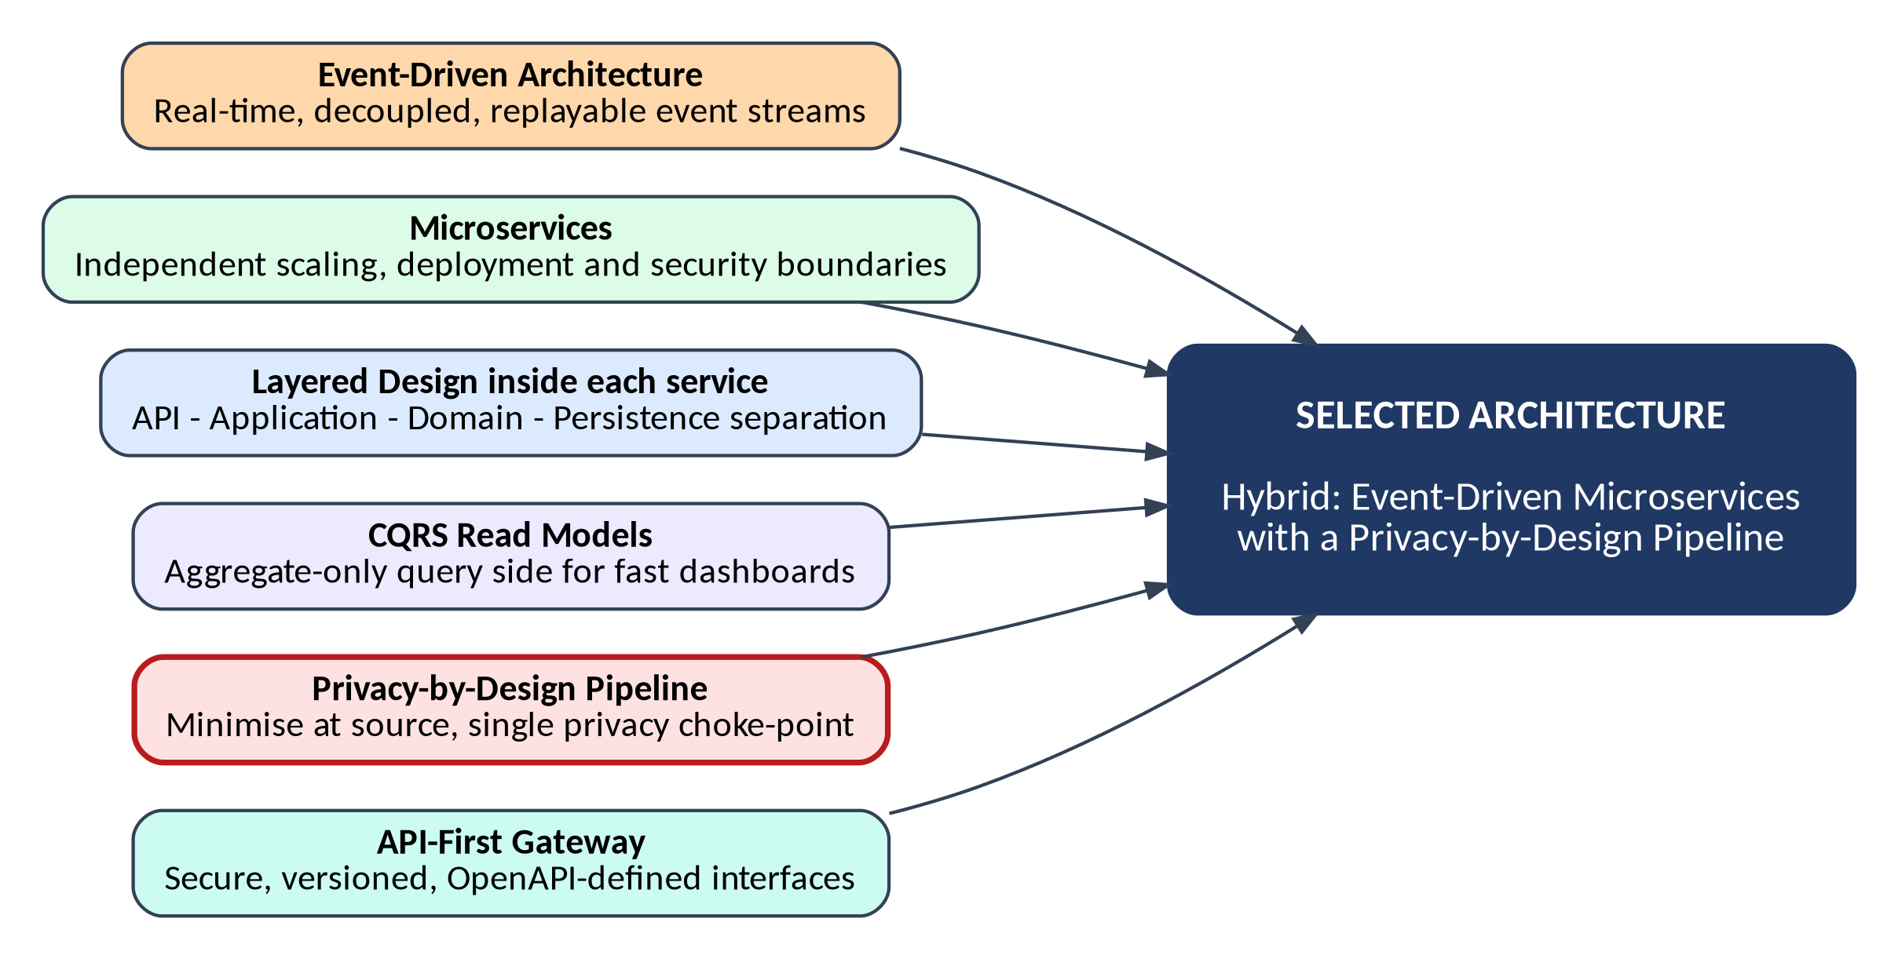
Figure 1: Composition of the selected hybrid architecture

2.4 Justification of the Selection
Table 9: How the selected architecture satisfies the key requirements
Requirement / driver | Why the selected architecture is suitable
Real-time analytics (O1, NFR1) | Events flow through a stream processor as they occur, so aggregates are updated within seconds. Batch or request/response designs would introduce minutes of delay.
Privacy by design (O2, O7, NFR6) | A single privacy choke point (edge gateway plus Privacy Filter) guarantees that only sanitised events reach the event log. Every downstream consumer is therefore privacy-safe by construction.
Scalability (O5, NFR2) | Kafka partitions (keyed by store) and stateless services scale horizontally. Hot spots, such as POS volume during a sale, scale independently of rarely used services.
Security and access control (O3) | Microservice boundaries create separate trust zones; the API gateway and IAM centralise authentication and authorisation. Services hold only the data they need.
Auditability and retention (O4) | Because all changes are events, audit records are naturally produced. A separate Retention Manager enforces TTLs without touching business services.
Reliability (NFR4) | A replicated, durable log decouples producers from consumers. If a service fails, events wait and are replayed rather than lost.
Maintainability and CI/CD (O6, NFR8) | Small services with explicit contracts (OpenAPI, Avro schemas) can be tested and released independently, supporting automated pipelines and blue-green deployment.
Integration and evolution | New data sources or analytics modules subscribe to existing topics without modifying current services (open/closed principle).

2.5 Architectural Patterns and Tactics Applied
Table 10: Patterns and tactics used in the design
Pattern / tactic | Purpose | Where applied
Publish-Subscribe / Event Streaming | Decouple producers and consumers; enable replay | Kafka topics between ingestion, stream processor and services
API Gateway | Single, secure, versioned entry point | All dashboard and partner requests
Privacy Gateway (anonymisation proxy) | Strip or transform personal data before storage | Edge Privacy Gateway and Privacy Filter
CQRS (read models) | Separate write path (events) from optimised read path (aggregates) | TimescaleDB and Redis serve queries
Database per service (polyglot persistence) | Autonomy and best-fit storage | PostgreSQL, TimescaleDB, Redis, object storage
Dead-Letter Queue | Isolate invalid or failing messages | Ingestion API and consumers
Retry with exponential back-off, Circuit Breaker, Bulkhead | Contain failures and prevent cascades | Service-to-service calls and external notifications
Idempotent consumer | Safe reprocessing under at-least-once delivery | Stream Processor and services (event_id de-duplication)
Sidecar / service mesh | Uniform mTLS, retries and telemetry | Kubernetes pods
Design by Contract | Reliable interfaces through schemas and validation | Avro schema registry, OpenAPI specifications, consumer-driven contract tests
Crypto-shredding | Irreversible deletion by destroying encryption keys | Retention Manager with KMS

3. Software Architecture Diagrams
This section presents the architecture at three levels of abstraction, following the C4 and UML component notation: the system context (who and what interacts with the platform), the logical architecture (layers, components, data stores and interfaces) and the deployment view (how the components run on infrastructure).

3.1 System Context Diagram
Figure 2 shows the platform as a single system with its human users and external systems. Arrows indicate the direction of the main data flow, and labels describe what is exchanged. Notably, the only sources of data are operational systems and anonymous sensor signals; no customer-facing system pushes personal profiles into the platform.
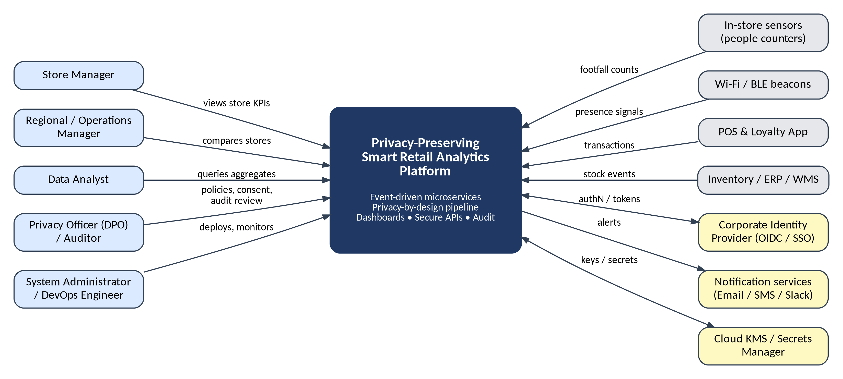
Figure 2: System context diagram of the platform

3.2 Logical Architecture Diagram
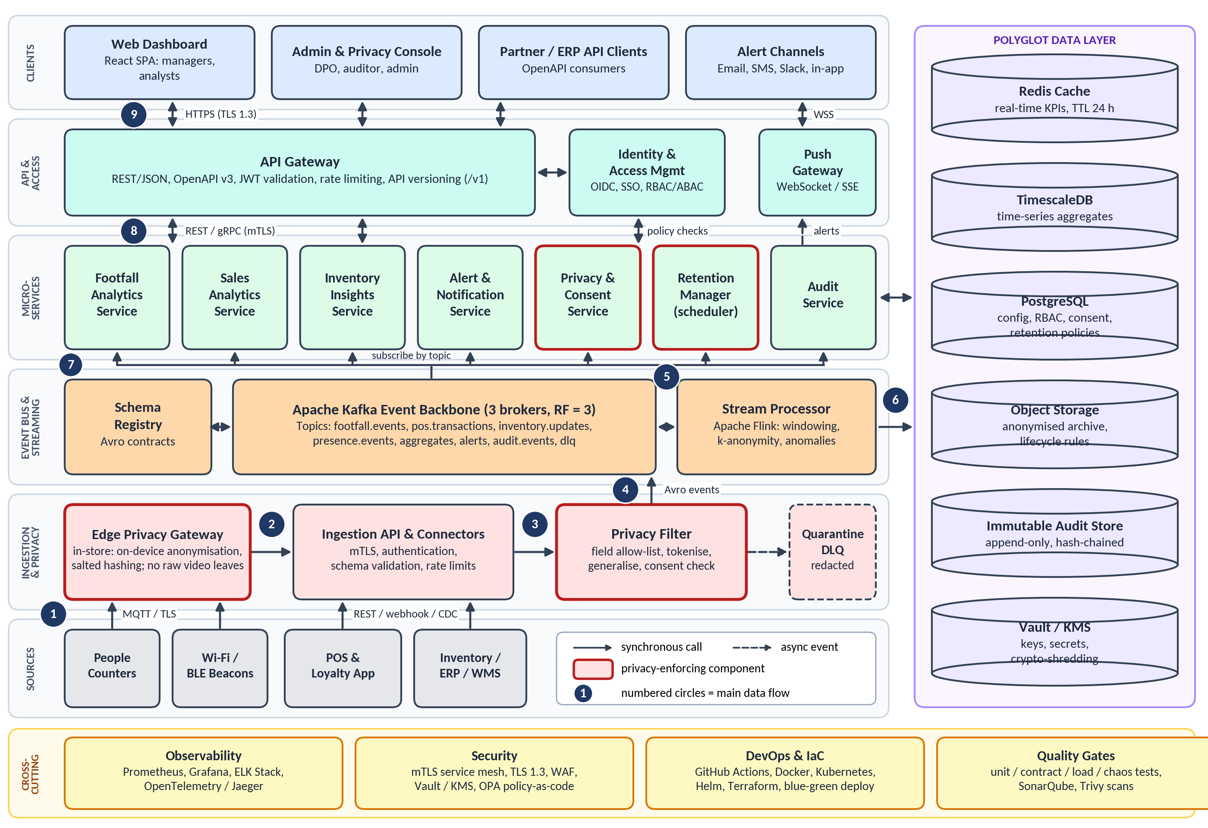
Figure 3: Logical architecture of the Privacy-Preserving Smart Retail Analytics Platform

3.3 Reading the Architecture Diagram
Figure 3 organises the system into horizontal layers. Data flows upward from the data sources at the bottom to the clients at the top, while the polyglot data layer on the right and the cross-cutting concerns at the bottom support every layer. Rectangles represent deployable components, cylinders represent data stores, solid arrows represent synchronous calls, dashed arrows represent asynchronous events, and components outlined in red are the ones that enforce privacy. The numbered circles in the figure trace the main data flow described below.
Table 11: Main data flow shown in Figure 3
No. | Step | Communication mechanism
1 | Sensors, Wi-Fi/BLE beacons, POS terminals, inventory and loyalty systems emit events | MQTT over TLS (in-store devices); REST, webhooks or change-data-capture (business systems)
2 | The Edge Privacy Gateway anonymises in-store signals and forwards sanitised batches | HTTPS with mutual TLS
3 | The Ingestion API authenticates the sender, validates the schema and passes the event to the Privacy Filter | In-cluster gRPC
4 | The Privacy Filter applies the field allow-list, tokenisation, generalisation and consent checks, then publishes the sanitised event | Avro events to Kafka topics
5 | The Stream Processor consumes the topics, aggregates events in time windows and enforces k-anonymity | Kafka consumer group
6 | Aggregates are written to the data layer (Redis for hot data, TimescaleDB for history) | Redis protocol; SQL over TLS
7 | Microservices subscribe to topics by consumer group and build their read models | Kafka consumer groups
8 | Microservices expose their results to the API Gateway | REST/JSON or gRPC over mTLS
9 | The gateway serves clients; the Push Gateway streams live updates | HTTPS (TLS 1.3); WebSocket / Server-Sent Events

3.4 Deployment View
Figure 4 shows how the logical components are deployed. Store-level components run on a small edge device. The cloud side runs on a managed Kubernetes cluster spread over three availability zones, with managed data services behind it. Namespaces provide logical isolation between ingestion, streaming, services and observability workloads.
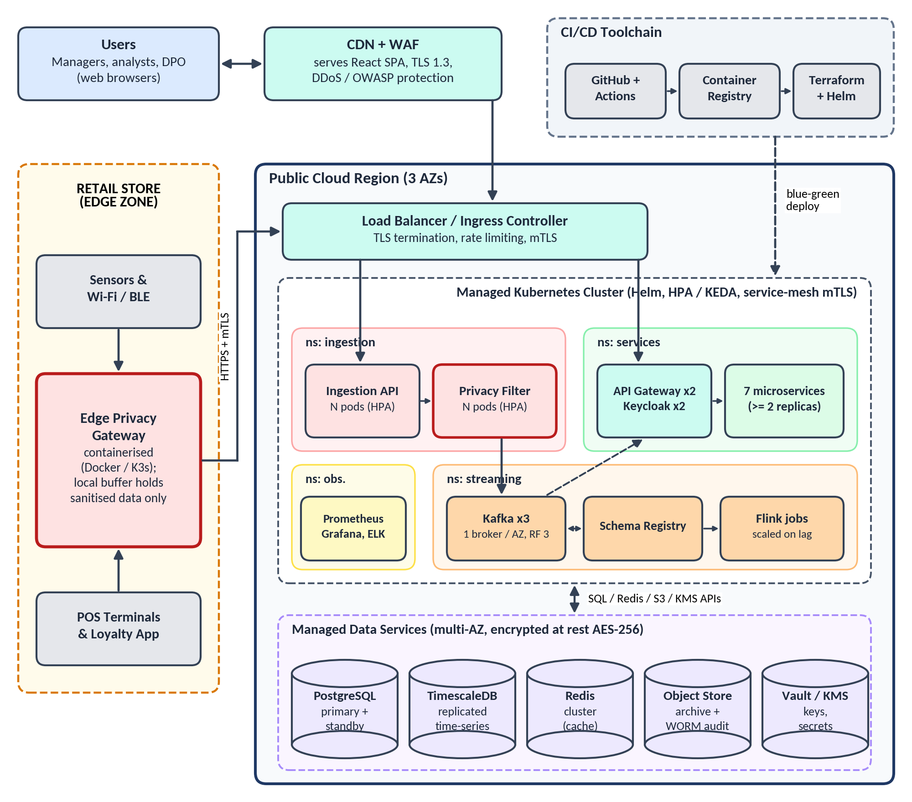
Figure 4: Deployment view of the platform (edge zone and cloud region)
- Edge zone: the Edge Privacy Gateway is containerised and keeps a local buffer of sanitised events only, so that a network outage never forces raw data to be stored.
- Entry points: a CDN with web application firewall serves the React single-page application; a load balancer and ingress controller terminate TLS and apply rate limiting.
- Kubernetes cluster: workloads are packaged as Docker images and released with Helm; the Horizontal Pod Autoscaler (and KEDA for Kafka consumer lag) scales pods in response to load.
- Data services: PostgreSQL, TimescaleDB, Redis, object storage and Vault/KMS are multi-AZ and encrypted at rest.
- CI/CD: GitHub Actions builds, tests and scans images, pushes them to a registry, and Terraform and Helm provision infrastructure and releases.

4. Components and Their Interactions

4.1 Component Catalogue
The tables below describe the purpose and responsibilities of every architectural component, grouped by layer. The technologies named are the proposed implementation choices; the architecture itself remains technology-neutral at the interface level.

A. Data Sources and Edge
Table 12: Data sources and edge components
Component | Purpose and responsibilities | Technology / interface
People counters / sensors | Emit anonymous entry, exit and zone-occupancy counts. Any vision processing is done on the device and outputs counts only. | MQTT over TLS
Wi-Fi / BLE beacons | Detect device presence signals used to estimate footfall and dwell time | MQTT over TLS
POS and loyalty app | Provide sales transactions (items, basket value, time); loyalty identifiers are tokenised downstream | REST, webhooks
Inventory / ERP / WMS | Provide stock levels, receipts and replenishment events | REST, change-data-capture
Edge Privacy Gateway | Anonymises in-store signals on the device (salted hashing with a daily-rotating salt, generalisation, discarding raw data); batches sanitised events; buffers during network outages | Containerised service (Docker / K3s); HTTPS + mTLS

B. Ingestion and Privacy Layer
Table 13: Ingestion and privacy components
Component | Purpose and responsibilities | Technology / interface
Ingestion API and Connectors | Single secure entry point for events: authenticates senders (mTLS, API credentials), validates schemas, applies rate limits, returns acknowledgements | REST / gRPC; OpenAPI; stateless pods
Privacy Filter Service | Enforces a field allow-list per event type; removes or tokenises identifiers; generalises timestamps and locations; checks the consent registry; drops opted-out events and logs the decision | gRPC service; consent cache from PostgreSQL
Quarantine / Dead-Letter Queue | Holds rejected events with redacted payloads for diagnosis; never stores raw identifiers | Kafka dlq topic with short TTL

C. Event Backbone and Stream Processing
Table 14: Event backbone and processing components
Component | Purpose and responsibilities | Technology / interface
Event Backbone | Durable, replicated, partitioned log carrying sanitised events (footfall, POS, inventory, presence, aggregates, alerts, audit) between components; supports replay | Apache Kafka (3 brokers, replication factor 3), topics keyed by store_id
Schema Registry | Stores Avro schemas and enforces backward-compatible evolution so producers and consumers keep a reliable contract | Confluent-compatible schema registry
Stream Processor | Computes windowed aggregates (1-minute, 5-minute, hourly); de-duplicates by event_id; suppresses cohorts smaller than k; detects anomalies; checkpoints its state | Apache Flink (or Kafka Streams)

D. Business Microservices
Table 15: Domain microservices
Microservice | Purpose and responsibilities | Data owned
Footfall Analytics Service | Serves entries, occupancy, zone heat-maps and dwell-time buckets for each store | Footfall aggregates (TimescaleDB, Redis)
Sales Analytics Service | Serves sales per hour, basket size, conversion rate (footfall to transactions) and trends | Sales aggregates
Inventory Insights Service | Tracks stock levels, sell-through and replenishment signals; flags low stock | Inventory read model
Alert and Notification Service | Evaluates alert rules against aggregates; sends notifications; deduplicates to avoid alert fatigue | Rule definitions (PostgreSQL)
Privacy and Consent Service | Manages purposes, consent and opt-out records, and data-subject requests; publishes policy changes to the Privacy Filter | Consent registry (PostgreSQL)
Retention Manager | Runs scheduled jobs that roll up, archive and purge data according to the retention policy; performs crypto-shredding through KMS | Retention policies (PostgreSQL)
Audit Service | Consumes audit events from all services and writes them to an append-only, hash-chained store; supports DPO search and reports | Immutable audit store

E. API, Access and Clients
Table 16: API, identity and client components
Component | Purpose and responsibilities | Technology / interface
API Gateway | Routes and secures client calls: JWT validation, rate limiting, request validation against OpenAPI, API versioning, response caching | Kong / NGINX / Spring Cloud Gateway; REST/JSON
Identity and Access Management | Single sign-on, multi-factor authentication, token issuance; evaluates role-based and attribute-based policies (role, store, region, purpose) | Keycloak (OIDC, OAuth 2.0); OPA for policies
Push Gateway | Delivers live KPI updates and alerts to browsers without polling | WebSocket / Server-Sent Events
Web Dashboard | Role-specific dashboards: store, region and enterprise views; charts, heat-maps and alerts | React single-page application
Admin and Privacy Console | Interfaces for the DPO and administrators: retention and consent policies, audit search, user and role management | React application using the same APIs

F. Data Layer and Cross-Cutting Components
Table 17: Data stores and cross-cutting components
Component | Purpose and responsibilities | Technology
Redis cache | Holds the latest KPIs for sub-second dashboard reads; 24-hour TTL | Redis cluster
TimescaleDB | Stores time-series aggregates (fine-grained and rolled-up) with partitioning by time and store | PostgreSQL extension
PostgreSQL | Transactional store for configuration, roles, consent and retention policies | PostgreSQL with standby
Object storage | Anonymised long-term archive and stream-processor checkpoints; lifecycle rules | S3-compatible storage
Immutable audit store | Append-only, hash-chained (WORM) record of accesses and policy actions | Object lock / ledger table
Vault / KMS | Secrets management, encryption keys, key rotation and key destruction | HashiCorp Vault or cloud KMS
Observability stack | Metrics, dashboards, log search and distributed traces; alerting on SLOs | Prometheus, Grafana, ELK, OpenTelemetry / Jaeger
Service mesh and policy engine | Automatic mTLS, retries and traffic policy between services; policy-as-code | Istio or Linkerd; Open Policy Agent
CI/CD and IaC | Automated build, test, scan and release; reproducible infrastructure | GitHub Actions, Docker, Helm, Terraform

4.2 Communication and Data Exchange
Two interaction styles are used. Asynchronous event streaming (Kafka with Avro messages) carries data between pipeline stages, because it decouples components and allows replay. Synchronous request/response (REST and gRPC over mTLS) is used where an immediate answer is required, such as dashboard queries and policy checks.
Table 18: Communication mechanisms between components
From → To | Style | Protocol and format | Notes
Sensors, beacons → Edge Gateway | Async publish | MQTT over TLS; JSON | Raw signals stay inside the store
Edge Gateway → Ingestion API | Sync, batched | HTTPS + mTLS; JSON | Sanitised batches; store-and-forward buffer
POS, ERP, loyalty → Ingestion API | Sync / CDC | REST, webhooks; JSON | Credentials per source system
Ingestion API → Privacy Filter | Sync | gRPC; Protobuf | Raw payload exists only in memory
Privacy Filter → Kafka | Async | Avro with schema registry | Only sanitised events are published
Kafka → Stream Processor | Async | Consumer group | Exactly-once semantics via checkpoints
Stream Processor → Data stores | Sync write | SQL / Redis protocol over TLS | Idempotent upserts
Kafka → Microservices | Async | Consumer groups | Each service has its own group and offsets
API Gateway ↔ Microservices | Sync | REST/gRPC over mTLS | Circuit breaker and timeouts
Clients → API Gateway | Sync | HTTPS, JSON, JWT bearer token | Versioned: /v1/...
Push Gateway → Browser | Async push | WebSocket / SSE | Token-authenticated stream
All services → Audit Service | Async | audit.events topic | Never blocks the request path

Example: how data minimisation changes an event
The following example shows a Wi-Fi presence signal as it moves through the pipeline. The raw record exists only in the memory of the edge device. The sanitised event carries a daily-rotating pseudonymous token, a one-minute time bucket and a zone instead of an exact position, and the final stored record is only an aggregate.
// 1. Raw signal (edge device memory only; never stored or transmitted)
{ "client_mac": "A4:5E:60:1B:7C:92", "rssi": -61, "ap": "AP-07", "ts": "2026-10-26T10:15:03Z" }

// 2. Sanitised event published to the presence.events topic
{ "event_id": "7b1e2c64-0f3a-4d8e-9a51-2f6c1d0b8e47", "event_type": "presence",
"store_id": "S102", "zone": "Z3",
"visitor_token": "c91f4a07...", // HMAC-SHA256(mac, daily_salt), truncated
"ts_bucket": "2026-10-26T10:15:00Z", // rounded to 1 minute
"schema_version": 2 }

// 3. Stored aggregate (token discarded after the window closes)
{ "store_id": "S102", "zone": "Z3", "window": "2026-10-26T10:15:00Z/PT1M",
"unique_visitors": 14, "k_anonymity_met": true }

4.3 Overall System Workflow
Figure 5 is a flowchart of the complete life of one event, from capture to dashboard and eventual deletion. The five decision points are where privacy, quality and alerting rules are applied; each rejection path writes an audit record. The steps are:
- An event is generated at a source (a person crosses a counter, a sale is completed, a stock level changes or a Wi-Fi probe is detected).
- The Edge Privacy Gateway decides whether it contains personal or quasi-identifying data; if so it is anonymised on the device (salted hash, generalisation) and the raw data is discarded.
- The sanitised event is sent securely to the Ingestion API, which rejects unauthenticated or malformed messages (quarantined with a redacted payload, and audited).
- The Privacy Filter applies the field allow-list and tokenisation, and drops the event if the consent registry says the individual has opted out.
- The event is published to a Kafka topic; the Stream Processor aggregates it in time windows, and any bucket representing fewer than k = 5 individuals is suppressed or merged into a coarser bucket.
- Aggregates are stored in Redis (hot) and TimescaleDB (history). Alert rules are evaluated and, if breached, the Alert Service notifies the right people.
- Dashboards update in real time through the Push Gateway, subject to role-based access checks.
- The Retention Manager later rolls up, archives and purges data according to policy, and every deletion is logged.

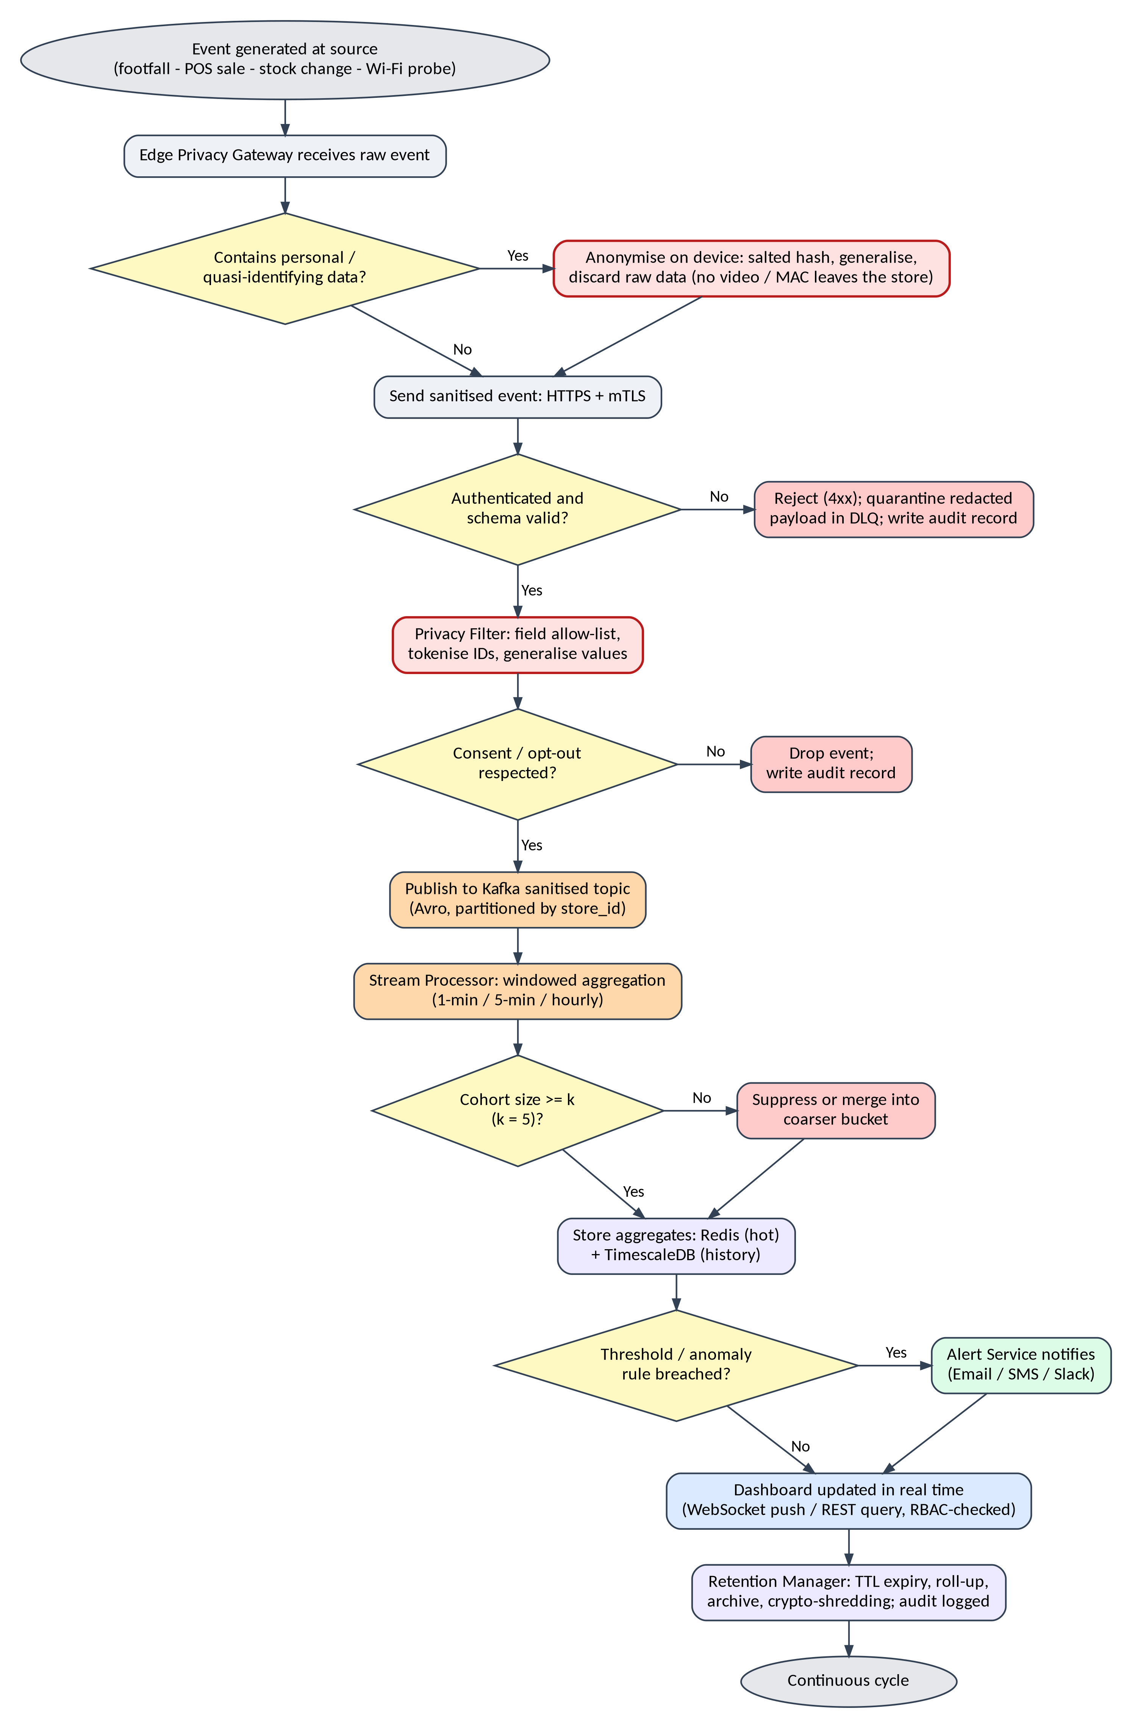
Figure 5: End-to-end workflow with privacy and quality checks

4.4 Interaction Sequences
Two sequence diagrams show how components collaborate at run time. Figure 6 follows an event through the ingestion and processing path; Figure 7 follows a dashboard request through the access-controlled query path.
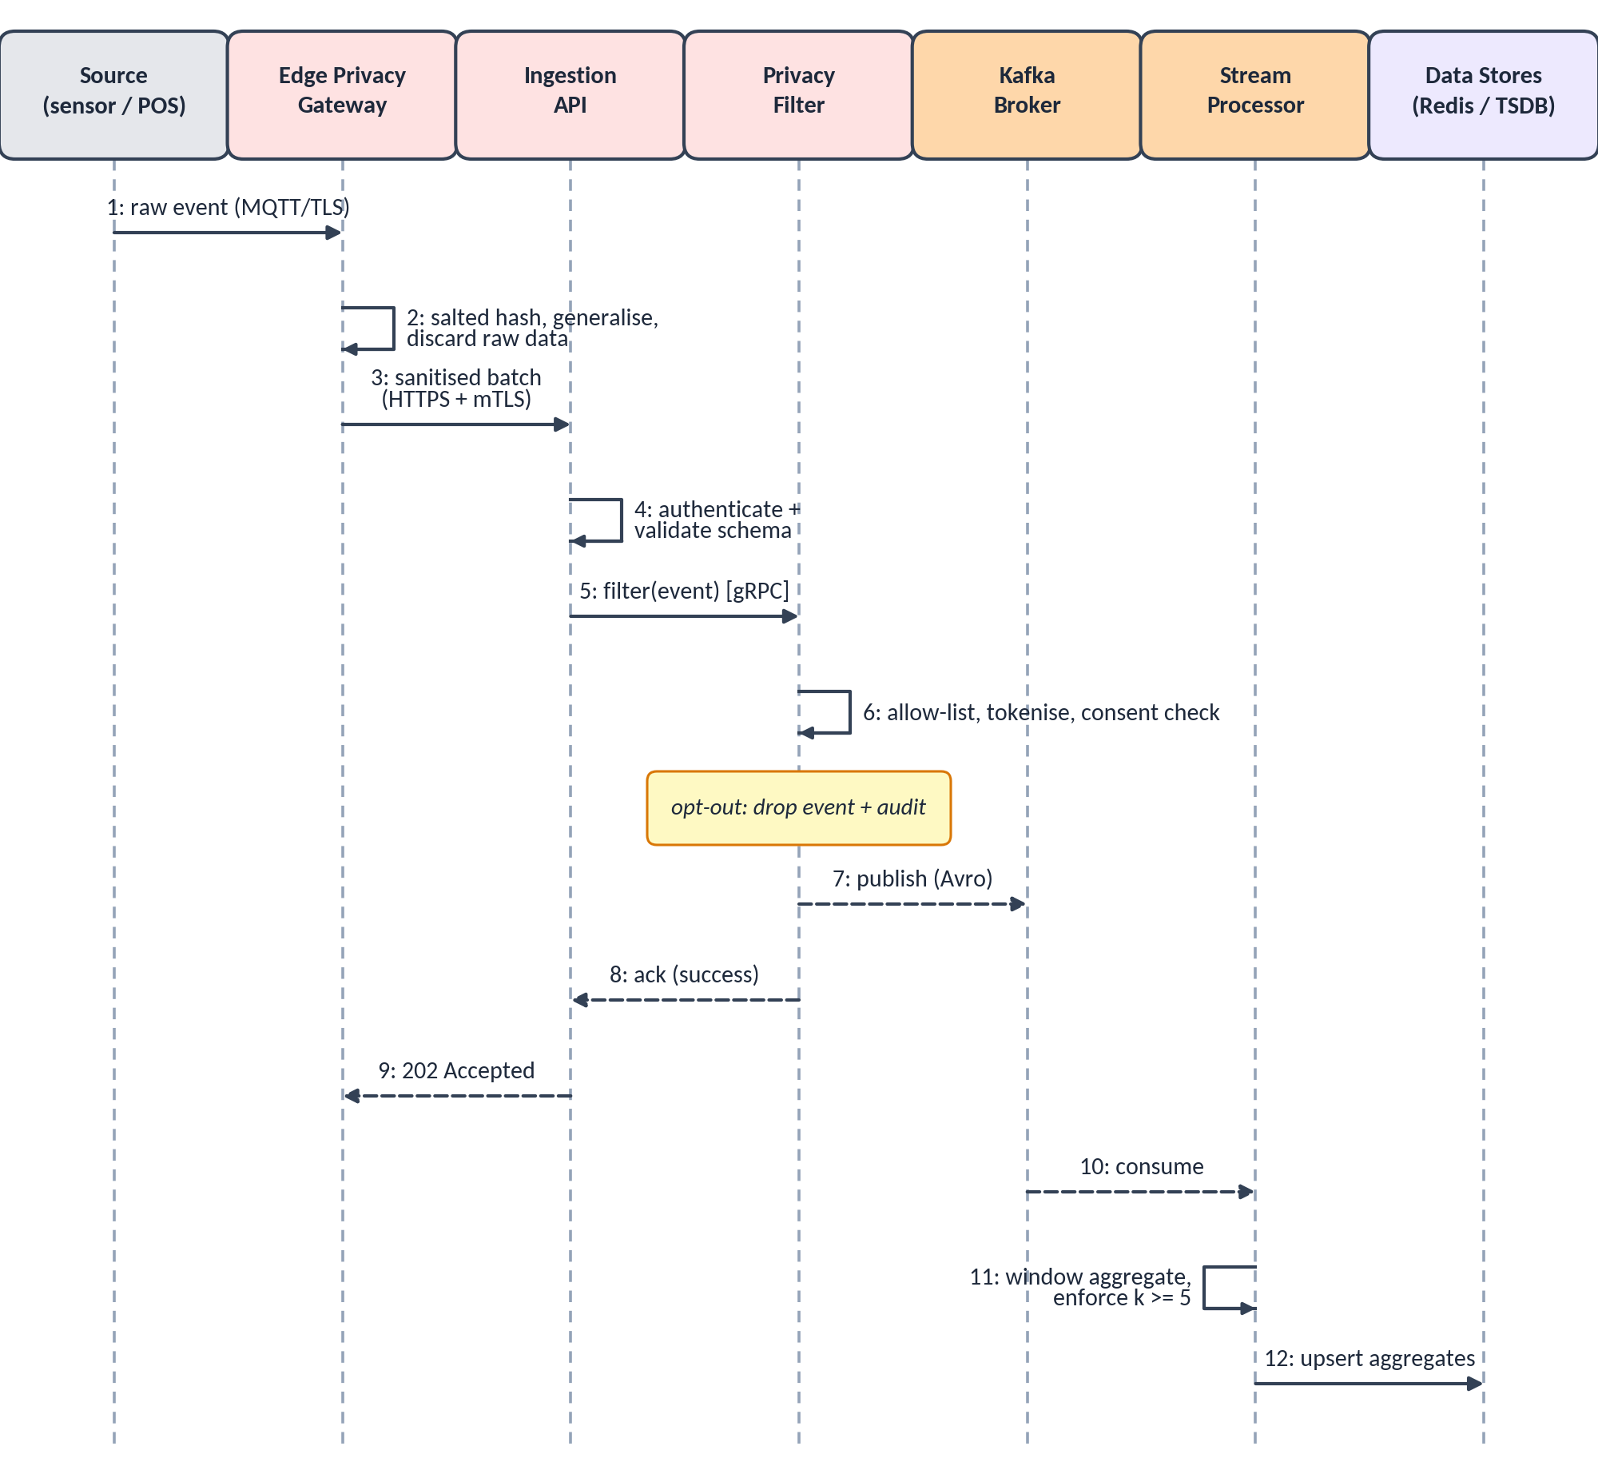
Figure 6: Sequence diagram: event ingestion and processing path
In Figure 6, steps 2, 4 and 6 are the three places where data is minimised or rejected, which shows that privacy is enforced before the event ever reaches the broker. Step 9 acknowledges the sender only after the event has been durably published (step 7), which gives the at-least-once guarantee. Steps 10 to 12 occur asynchronously and do not delay the sender.
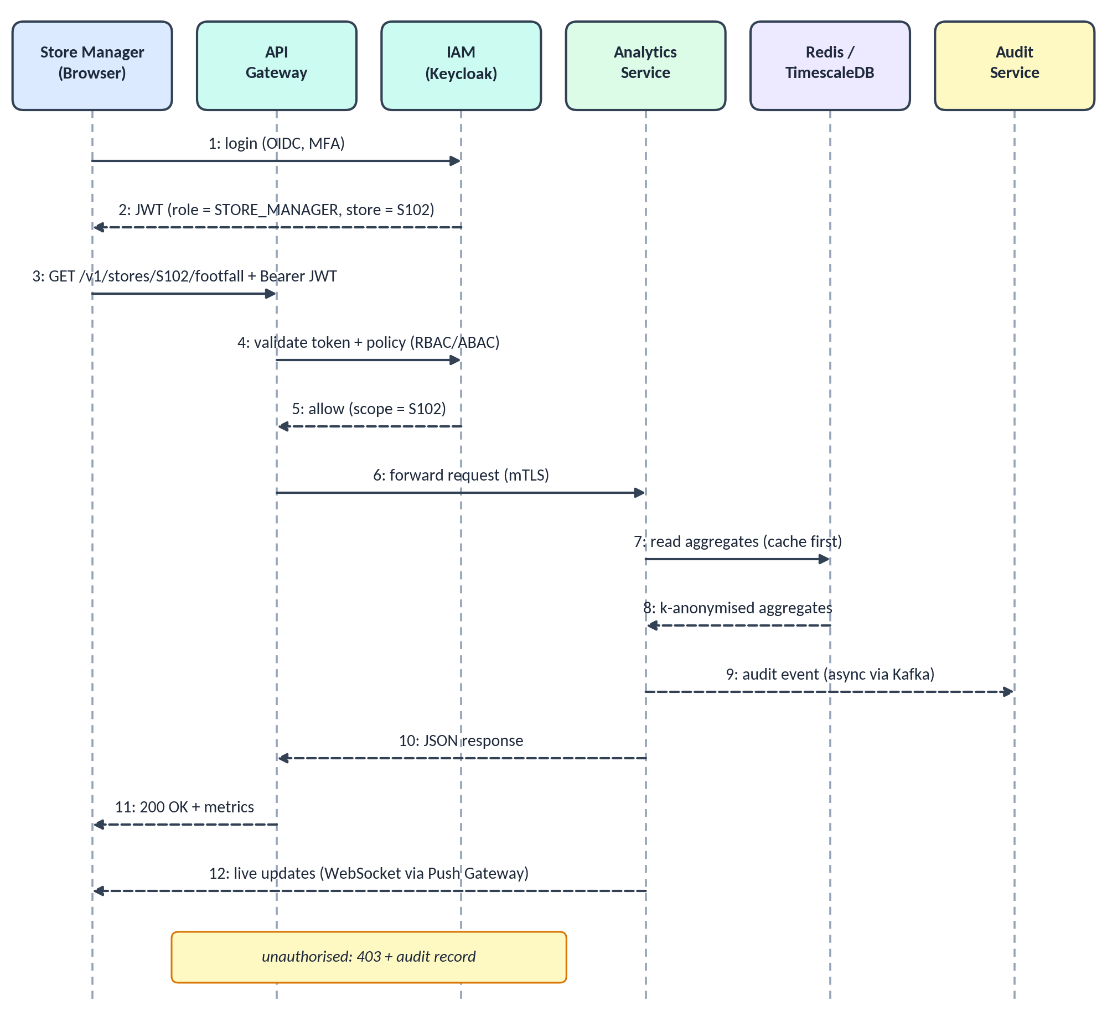
Figure 7: Sequence diagram: authenticated dashboard query path
In Figure 7, the user authenticates once through the identity provider and receives a token containing role and store scope. The gateway validates the token and policy on every request (steps 4 and 5) so that a store manager can read only the aggregates of their own store. The Analytics Service reads pre-computed, k-anonymised aggregates (cache first), writes an audit event without blocking the response (step 9) and later pushes live updates (step 12).

4.5 Data Lifecycle and Retention
Data protection is strongest when data does not exist. Figure 8 shows the lifecycle of data through five stages, with the retention period and privacy control of each. Retention values are secure defaults that the DPO can change per jurisdiction through the Admin and Privacy Console; the Retention Manager then applies them automatically.
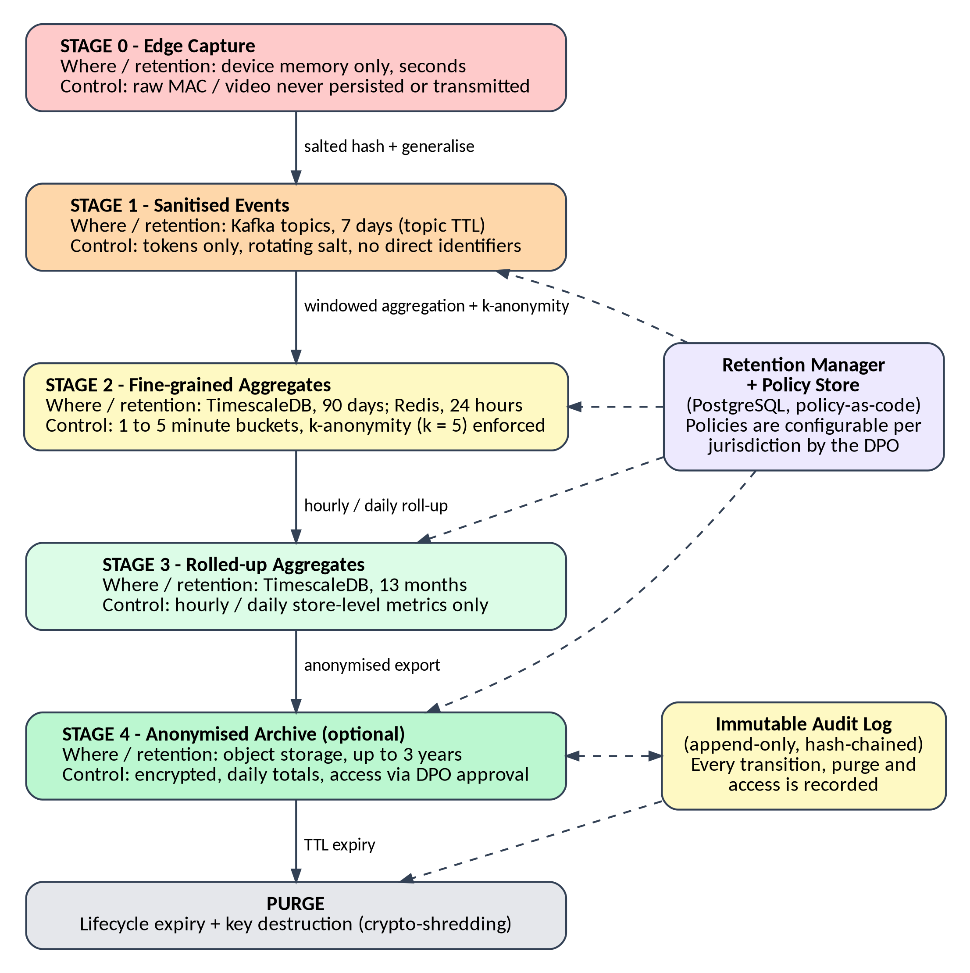
Figure 8: Data lifecycle, retention periods and privacy controls
Table 19: Default retention policy by data class
Data class | Store | Default retention | Deletion mechanism
Raw device signals | Edge device memory | Seconds (never persisted) | Overwritten in memory
Sanitised events | Kafka topics | 7 days | Topic retention (TTL)
Fine-grained aggregates | TimescaleDB; Redis | 90 days; 24 hours | Time-partition drop; key expiry
Rolled-up aggregates | TimescaleDB | 13 months | Scheduled purge job
Anonymised archive (optional) | Object storage | Up to 3 years | Lifecycle rule plus key destruction
Audit records | Immutable audit store | 24 months (configurable) | WORM expiry after retention lock
Consent records | PostgreSQL | Life of consent plus legal period | Policy-driven deletion

4.6 Access Control Model
Access is governed by role-based access control, refined by attributes (store, region and purpose). Two rules are fixed by design: no role can read event-level or identifying data because it does not exist in the platform, and administrators who manage infrastructure cannot read business data.
Table 20: Role-permission matrix
Permission | Store Mgr | Regional Mgr | Analyst | DPO | Auditor | Admin
View own-store dashboards | Yes | Yes | Yes | No | No | No
View multi-store / regional dashboards | No | Region | Yes | No | No | No
Query and export aggregates | Own store | Region | Yes | No | No | No
Configure alert thresholds | Own store | Region | No | No | No | No
Manage retention and consent policies | No | No | No | Yes | No | No
Read audit logs | No | No | No | Yes | Yes | No
Manage users and roles | No | No | No | Approve | No | Yes
Deploy and configure infrastructure | No | No | No | No | No | Yes
Access identifiable or raw data | No | No | No | No | No | No

5. Quality Attribute Analysis
This section evaluates how the proposed architecture addresses the six required quality attributes. For each attribute the architectural tactics are identified, linked to components, and made verifiable through measurable targets and test techniques. Table 21 gives an overview and the later subsections give the detail.
Table 21: Quality attributes, tactics and verification
Attribute | Principal tactics | Key components | How it is verified
Scalability | Partitioned log, stateless services, autoscaling, CQRS read models, caching | Kafka, Flink, microservices, Redis, Kubernetes HPA/KEDA | Load tests (k6) at 5× peak
Security | Edge anonymisation, mTLS, OAuth2/OIDC, RBAC/ABAC, encryption, secrets vault, immutable audit | Edge gateway, Privacy Filter, API Gateway, IAM, KMS, audit store | SAST/DAST, dependency and image scans, penetration tests, fuzzing
Performance | Stream processing, pre-aggregation, in-memory cache, async audit | Flink, Redis, TimescaleDB | Latency budgets, performance tests, tracing
Reliability | Durable replicated log, idempotent consumers, retries, DLQ, schema contracts | Kafka, Schema Registry, DLQ, services | Contract tests, chaos experiments, replay tests
Maintainability | Bounded services, layered code, API-first, IaC, CI/CD, observability | All services, Git, pipeline | Code-quality gates, mutation tests, coverage reports
Availability | Multi-AZ redundancy, replication, health probes, rolling and blue-green releases | Kubernetes, Kafka, PostgreSQL, load balancer | Failover drills, uptime SLO monitoring

5.1 Scalability
The platform scales horizontally at every stage, so growth in stores or event volume is met by adding instances rather than by redesign.
- Partitioned event log: topics are partitioned by store_id (initially 24 partitions for high-volume topics, expandable), so ordering is preserved per store while consumers scale in parallel.
- Stateless services and autoscaling: ingestion, privacy and microservice pods hold no session state and are scaled by the Horizontal Pod Autoscaler; stream-processing workers are scaled by consumer lag using KEDA.
- Independent scaling: a busy POS pipeline during a festive-season sale scales without scaling rarely used services such as the Retention Manager.
- Read/write separation (CQRS): dashboards read pre-computed aggregates, so heavy read traffic never competes with event ingestion.
- Data scaling: TimescaleDB partitions data by time and store; old partitions are rolled up or dropped, keeping hot data small.
- Onboarding new stores: a new store is a configuration entry (credentials, zones, topics) rather than new code.

5.2 Security and Privacy
Security uses defence in depth: controls exist at the edge, network, application, data and operations levels, and privacy is enforced structurally rather than by policy alone.
- Edge and pipeline: on-device anonymisation, a field allow-list and tokenisation ensure that no direct identifiers enter the cloud; daily-rotating salts prevent tracking a visitor across days.
- Transport and network: TLS 1.3 for clients, mutual TLS between services through the mesh, network policies per namespace, and a web application firewall at the edge.
- Identity and access: single sign-on with multi-factor authentication; short-lived JWTs; RBAC and ABAC evaluated at the gateway and again in services (least privilege).
- Data protection: AES-256 encryption at rest, keys held in KMS, secrets in Vault, k-anonymity enforcement and per-class retention; crypto-shredding for irreversible deletion.
- Accountability: every access and policy change is written to an append-only, hash-chained audit store; tampering is detectable.
- Secure development: SAST, dependency and container scanning, secret scanning and fuzz testing are mandatory pipeline gates.
Table 22: Threat analysis (STRIDE) and mitigations
Threat | Example in this system | Mitigation
Spoofing | Fake sensor or user impersonation | mTLS device certificates, OIDC with MFA, signed tokens
Tampering | Altering events in transit or audit records | TLS/mTLS, schema validation, hash-chained audit log
Repudiation | Denying a policy change or data export | Immutable audit trail with user and purpose
Information disclosure | Re-identification from small cohorts or leaked data | Edge anonymisation, k ≥ 5 suppression, encryption, no identifiers stored
Denial of service | Event flood or API abuse | Rate limiting, WAF, autoscaling, back-pressure and quotas
Elevation of privilege | Manager accessing other stores' data | RBAC/ABAC with store scope, least-privilege service accounts, OPA policies

5.3 Performance
Performance is managed through a latency budget: the 5-second end-to-end target is divided among pipeline stages so that each can be designed, monitored and tuned independently (Table 23).
Table 23: End-to-end latency budget for a footfall update
Stage | Budget | Design choice
Edge capture and batching | 0.5 s | Small batches over a persistent connection
Ingestion API and Privacy Filter | 0.15 s | Stateless, in-memory allow-list and consent cache
Kafka publish and replication | 0.05 s | Partitioned log; acknowledgements from in-sync replicas
Stream processing (window trigger) | 2.0 s | Micro-window early firing for live KPIs
Aggregate write and push | 0.3 s | Redis write, then WebSocket push
Browser rendering | 0.5 s | Incremental chart updates in the React client
Total | 3.5 s | Within the 5 s target, leaving 1.5 s margin

- Pre-aggregation: dashboards never scan raw events; queries hit small aggregate tables and Redis (target API p95 ≤ 300 ms).
- Caching: Redis for hot KPIs and gateway response caching for repeated queries.
- Non-blocking design: audit logging and notifications are asynchronous so they never extend the request path.
- Efficient serialisation: Avro for events and Protobuf for internal gRPC reduce payload size and parsing cost.

5.4 Reliability
- No data loss: events are acknowledged to senders only after being durably written to the replicated log; consumers commit offsets after processing.
- Idempotent processing: each event carries a unique event_id, so at-least-once delivery can be reprocessed without double counting.
- Failure isolation: circuit breakers, timeouts and bulkheads prevent a failing service (for example an email provider) from cascading to others.
- Dead-letter queue and replay: invalid events are quarantined with redacted payloads; correct events can be replayed from the log after a fix.
- Design by contract: Avro schemas with backward-compatibility checks, OpenAPI request validation and consumer-driven contract tests prevent breaking changes between services.
- Resilience testing: chaos experiments (pod, node and zone failures) in the pipeline verify that these mechanisms work.

5.5 Maintainability
- Modularity: each microservice owns a single business capability and its data; internally it follows layers (API, application, domain, persistence), supporting small, understandable code bases.
- API-first and versioning: OpenAPI contracts are written before implementation; breaking changes require a new /v2 version, and old versions are deprecated on a schedule.
- Infrastructure as code: Terraform and Helm make environments reproducible and reviewable.
- Automated quality gates: the CI/CD pipeline in Figure 9 runs tests, static analysis and security scans on every change, and releases through blue-green deployment with automatic rollback.
- Observability: Prometheus, Grafana, ELK and distributed tracing shorten root-cause analysis.
- Documentation: decisions are recorded as architecture decision records (Section 6.1), and code and APIs are documented as part of the definition of done.
Table 24: Testing strategy supporting maintainability and reliability
Level | Technique | Typical tools | Run when
Unit | Test-driven development; mocks for dependencies | JUnit / PyTest, Jest | Every commit
Integration | Service with real Kafka and database in containers | Testcontainers | Every pull request
Contract | Consumer-driven contracts; schema compatibility | Pact, schema registry checks | Every pull request
End-to-end / BDD | Behaviour scenarios for key user journeys | Cucumber, Cypress | Staging deployment
Performance | Load and stress tests at 5× expected peak | k6, JMeter | Release candidate
Security | SAST, DAST, dependency and image scans, fuzzing | SonarQube, OWASP ZAP, Trivy | Every build; nightly
Quality of tests | Mutation testing to validate test strength | PIT / mutmut | Nightly
Resilience | Chaos engineering: kill pods, nodes, zones | Chaos Mesh / Litmus | Pre-release; scheduled

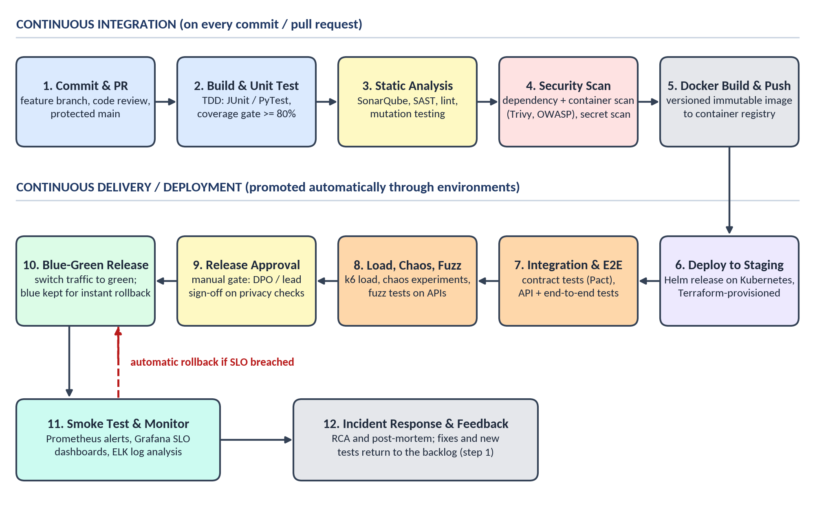
Figure 9: Containerised CI/CD pipeline with quality gates and blue-green release

5.6 Availability
The availability target is 99.9% per month (about 43 minutes of permitted downtime). It is achieved by removing single points of failure at every tier and by releasing without downtime (Table 25).
Table 25: Redundancy and failure behaviour by component
Component | Redundancy | Behaviour on failure
Edge Privacy Gateway | Local buffer; optional second device for large stores | During a network outage, sanitised events are buffered (up to 24 hours) and sent when the link returns
Ingestion API, Privacy Filter, microservices | At least 2 replicas across zones; PodDisruptionBudgets | Load balancer removes unhealthy pods; Kubernetes restarts them
Kafka | 3 brokers in 3 zones; replication factor 3; min in-sync replicas 2 | Tolerates loss of one zone without data loss
Stream Processor | Parallel workers; checkpoints in object storage | Restarts from the last checkpoint; no loss, no duplicate counting
PostgreSQL and TimescaleDB | Primary plus standby; continuous archiving | Automatic failover; point-in-time recovery
Redis cache | Cluster with replicas | Cache is rebuildable from TimescaleDB, so loss is non-critical
Releases | Blue-green and rolling updates | Traffic switches only after health checks pass; instant rollback

Recovery objectives: events are protected by the replicated log (effectively zero loss); database recovery point is within 5 minutes; recovery time is under 15 minutes for the loss of a zone (automatic) and within 4 hours for a regional disaster (rebuild from infrastructure-as-code and backups).

5.7 Quality Attribute Scenarios
The scenarios below express the quality requirements in a testable form (stimulus, response and measure), following the quality attribute scenario method of Bass, Clements and Kazman.
Table 26: Quality attribute scenarios
Attribute | Stimulus | Architectural response | Measure
Scalability | Event rate rises 5× during a festive-season sale | Autoscalers add ingestion pods and stream workers; Kafka absorbs the burst | No event loss; scale-out within 2 minutes; latency ≤ 5 s
Security | A store manager requests another store's data | Gateway and policy engine deny; audit event written | 403 returned; 100% of attempts logged
Performance | 200 managers open dashboards at the same time | Queries served from Redis and aggregate tables | p95 API response ≤ 300 ms
Reliability | A consumer crashes during processing | Offsets not committed; replayed on restart; event_id de-duplication | No loss or double counting
Maintainability | A new data source (for example, queue-length cameras) must be added | New adapter and topic; existing services unchanged | Change delivered in one sprint with no regression
Availability | One availability zone fails | Traffic and leadership move to remaining zones | Dashboards stay available; recovery under 15 minutes

6. Justification of Architectural Decisions

6.1 Rationale Behind the Architectural Choices
Table 27 records the main architectural decisions in the form of architecture decision records (ADRs). Each decision lists the alternatives considered and the rationale, together with the consequence that must be managed.
Table 27: Architecture decision records
ID | Decision | Alternatives considered | Rationale and consequence
ADR-1 | Hybrid event-driven microservices architecture | Layered monolith; pure microservices; serverless | Best fit for real-time, independently scalable, privacy-isolated workloads (score 4.60). Consequence: operational complexity, mitigated by Kubernetes, Helm and automation.
ADR-2 | Privacy enforced at the edge and at a central Privacy Filter before the event log | Anonymise later in the data warehouse | Prevents identifiers from ever being stored; a single choke point is easy to audit. Consequence: small added latency (about 0.15 s).
ADR-3 | Apache Kafka as the event backbone | RabbitMQ; cloud pub/sub; database polling | Durable, partitioned, replayable log with high throughput. Consequence: requires cluster operation or a managed service.
ADR-4 | Stream processing with windowed aggregation (Flink) | Nightly batch jobs; per-request computation | Gives second-level freshness and stateful k-anonymity checks. Consequence: stateful job management and checkpoints.
ADR-5 | Aggregate-first storage with CQRS read models | Store all events and query them directly | Reduces both privacy exposure and query cost. Consequence: individual-level drill-down is not possible by design.
ADR-6 | Polyglot persistence (Redis, TimescaleDB, PostgreSQL, object storage) | One relational database for everything | Each store matches its access pattern. Consequence: more technologies to operate; data ownership per service.
ADR-7 | API gateway with OAuth 2.0 / OIDC, RBAC and ABAC | Per-service authentication; basic API keys | Central, consistent enforcement and SSO. Consequence: gateway becomes critical, so it is deployed redundantly.
ADR-8 | Separate, immutable audit store | Application logs in the main database | Tamper-evident accountability for the DPO and auditors. Consequence: extra storage and an extra service.
ADR-9 | Retention enforced by TTLs plus crypto-shredding | Manual deletion scripts | Automatic, verifiable, irreversible deletion, including backups. Consequence: key management must be reliable.
ADR-10 | Kubernetes with containers, Helm and Terraform | Virtual machines with manual configuration | Portable, scalable and reproducible, and it supports blue-green releases. Consequence: skills and tooling investment.
ADR-11 | Contract-first interfaces (OpenAPI and Avro schema registry) | Informal, code-first interfaces | Prevents integration breakage and eases partner integration. Consequence: discipline in schema evolution.

6.2 Trade-off Analysis
Table 28: Trade-offs considered and how they were resolved
Trade-off | Options | Decision and mitigation
Privacy vs analytical granularity | Individual journeys vs aggregates only | Aggregates with k ≥ 5. Operational questions are still answered fully; personalisation and cross-day journey analysis are deliberately excluded.
Complexity vs scalability | Monolith vs microservices | Microservices, kept manageable through a small number of well-bounded services, common templates, Helm charts and automation.
Consistency vs availability | Strong vs eventual consistency | Analytics tolerate eventual consistency (seconds); consent, roles and policies live in PostgreSQL with strong consistency.
Latency vs privacy overhead | Skip filtering vs filter every event | Filter every event; keep it fast with in-memory allow-lists and cached consent (about 0.15 s).
Edge processing vs cloud processing | Cheaper edge vs raw data in the cloud | Edge anonymisation, accepting a small edge-device cost to avoid exposing raw data.
Real-time vs batch | Separate batch and speed layers vs single streaming path | Single streaming path with replay from the log, avoiding duplicated logic.
Cost vs resilience | Single zone vs three zones | Three-zone deployment for the data and messaging tiers; stateless tiers scale down off-peak to control cost.
Build vs buy | Self-managed vs managed Kafka, databases | Prefer managed services where available, keeping interfaces standard to avoid lock-in.

6.3 Risks and Mitigations
Table 29: Principal architectural risks
Risk | Impact | Mitigation
Re-identification from small groups or linkage with other data | Privacy breach | k-anonymity suppression, daily-rotating salts, no cross-day tokens, periodic privacy review and DPIA
Misconfigured retention or consent policy | Regulatory exposure | Policy-as-code with review, automated tests of retention jobs, audit of every policy change
Event schema drift between teams | Pipeline failures | Schema registry with compatibility checks and consumer-driven contract tests
Operational complexity of many services | Slow delivery, outages | Automation (IaC, CI/CD), standard templates, strong observability, incremental rollout of services
Insider misuse | Data exposure | Least privilege, no raw data to expose, segregation of duties, immutable audit
Cloud or vendor lock-in | Reduced flexibility | Containers, open standards and open-source components; abstraction at storage and messaging interfaces
Edge device failure | Gap in store data | Local buffering, health monitoring, spare device and remote re-provisioning

6.4 Support for Future Enhancements and System Integration
The architecture is designed so that new capabilities are added by subscribing to existing events or by adding adapters, not by modifying working services (the open/closed principle). This keeps the cost of change low and protects the privacy guarantees already in place.
Table 30: Future enhancements and how the architecture supports them
Enhancement | How it is supported | Impact on existing system
Demand forecasting with machine learning | New service subscribes to the aggregates topic and trains on aggregated history | None to existing services
New data sources (queue cameras, smart shelves, e-commerce) | New connector and topic; schema registered; same Privacy Filter applies | Configuration only
Stronger privacy techniques (differential privacy, federated analytics) | Added inside the Stream Processor or at the edge, behind the same interfaces | Local to one component
Multi-region and multi-tenant operation | Regional clusters with Kafka mirroring; tenant-scoped topics and policies | Deployment and configuration
Integration with ERP, CRM and BI tools | Versioned OpenAPI endpoints, webhooks and event export of aggregates | New API consumers only
New regulations or jurisdictions | Policy-as-code (OPA) and configurable retention and consent rules | Policy updates, no code redeployment
Edge AI and richer on-device analytics | Edge Gateway runs additional containerised models; only counts leave the device | Edge image update

6.5 Long-Term Maintainability and Evolution
- Independent evolution: services can be refactored, rewritten or replaced behind stable contracts; the strangler-fig approach allows gradual replacement of legacy POS or ERP integrations.
- Technical debt control: quality gates, regular refactoring in sprints, dependency updates automated by the pipeline and periodic review of the ADRs.
- Knowledge preservation: architecture decision records, OpenAPI documentation, runbooks and post-incident reviews are version-controlled with the code.
- Operational learning: monitoring, tracing and incident reviews feed new items into the product backlog, closing the DevOps loop.
- Sustainable operations: autoscaling to the actual load, scale-down off-peak, right-sized containers and efficient pipelines (cached builds, targeted tests) reduce the energy and cost footprint.

6.6 Conclusion
The proposed hybrid architecture, event-driven microservices with a privacy-by-design pipeline, resolves the central tension of the problem: it delivers real-time retail analytics while ensuring that identifiable customer data is neither collected beyond need nor stored. Privacy is enforced structurally at the edge and at a single filter, access is controlled and audited, retention is automated, and the platform scales, recovers and evolves through loosely coupled services, contract-first interfaces and a fully automated delivery pipeline. The trade-offs, chiefly the loss of individual-level analysis and the higher operational complexity, were identified, justified and mitigated, which makes the design suitable as the foundation for implementation in the subsequent capstone phases.

References
[1] L. Bass, P. Clements and R. Kazman, Software Architecture in Practice, 4th ed. Addison-Wesley, 2021.
[2] S. Newman, Building Microservices, 2nd ed. O'Reilly Media, 2021.
[3] M. Kleppmann, Designing Data-Intensive Applications. O'Reilly Media, 2017.
[4] G. Hohpe and B. Woolf, Enterprise Integration Patterns. Addison-Wesley, 2003.
[5] N. Dragoni et al., "Microservices: Yesterday, Today, and Tomorrow," in Present and Ulterior Software Engineering, Springer, 2017.
[6] A. Cavoukian, "Privacy by Design: The 7 Foundational Principles," Information and Privacy Commissioner of Ontario, 2009.
[7] L. Sweeney, "k-Anonymity: A Model for Protecting Privacy," International Journal of Uncertainty, Fuzziness and Knowledge-Based Systems, vol. 10, no. 5, 2002.
[8] J. Humble and D. Farley, Continuous Delivery. Addison-Wesley, 2010.
[9] B. Beyer et al., Site Reliability Engineering: How Google Runs Production Systems. O'Reilly Media, 2016.
[10] Regulation (EU) 2016/679 (General Data Protection Regulation); Digital Personal Data Protection Act, 2023 (India).

Appendix: Coverage of the Assessment Rubric
Table 31: Where each evaluation criterion is addressed in this report
Evaluation criterion (weight) | Addressed in | Evidence provided
System Requirement Analysis (30%) | Section 1 | Objectives, stakeholders, MoSCoW-prioritised functional requirements, measurable non-functional requirements, privacy requirements, ranked quality attributes, assumptions
Selection of Software Architecture (25%) | Section 2 | Eight styles compared, weighted decision matrix, hybrid style chosen with requirement-by-requirement justification and pattern list
Architecture Diagram and Component Design (20%) | Section 3 and 4.1 | Context, logical, deployment diagrams with notation legend; full component catalogue with responsibilities and technologies
Component Interaction and Quality Attribute Analysis (15%) | Sections 4 and 5 | Communication table, workflow flowchart, two sequence diagrams, lifecycle, access model; six quality attributes with tactics, scenarios and measures
Architectural Justification and Technical Presentation (10%) | Section 6 | Decision records, trade-offs, risks, future enhancements, integration and long-term maintainability, conclusion and references

Rubrics for Calculation
Evaluation Criteria | Excellent (4 Marks) | Good (3 Marks) | Satisfactory (2 Marks) | Needs Improvement (1 Mark)
System Requirement Analysis (30%) | Thoroughly analyzes the problem statement, accurately identifies functional and non-functional requirements, and clearly explains quality attributes influencing the architecture. | Analyzes most requirements with minor omissions or limited explanation. | Identifies only basic requirements with partial analysis. | Requirement analysis is incomplete, inaccurate, or lacks clarity.
Selection of Software Architecture (25%) | Selects the most appropriate architectural style with strong technical justification aligned to system requirements. | Selects a suitable architecture with reasonable justification. | Architecture is partially suitable with limited justification. | Inappropriate architecture selected or justification is missing.
Architecture Diagram and Component Design (20%) | Produces a clear, complete, and well-structured architecture diagram with all major components, interfaces, and interactions accurately represented. | Diagram is mostly complete with minor omissions or notation issues. | Diagram includes only essential components and lacks sufficient detail. | Diagram is incomplete, unclear, or technically incorrect.
Component Interaction and Quality Attribute Analysis (15%) | Clearly explains component responsibilities, interactions, and thoroughly discusses scalability, security, performance, reliability, maintainability, and availability. | Explains most components and quality attributes with minor gaps. | Provides limited explanation of interactions and addresses only some quality attributes. | Component interactions and quality attributes are poorly explained or missing.
Architectural Justification and Technical Presentation (10%) | Provides strong justification for architectural decisions, discusses trade-offs and future enhancements, and presents a well-organized, professional report. | Provides adequate justification with minor gaps; report is well organized. | Limited justification with minimal discussion of trade-offs or future scope; report needs improvement. | Justification is weak or absent; report lacks organization and technical clarity.

Criteria | Mark
System Requirement Analysis (30%) | /5
Selection of Software Architecture (25%) | /5
Architecture Diagram and Component Design (20%) | /5
Component Interaction and Quality Attribute Analysis (15%) | /5
Architectural Justification and Technical Presentation (10%) | /5
TOTAL | /25

